AdmitGuard — Front-End Design Guidelines
Version: 1.0
Audience: Frontend Developers, Designers
Reference Inspiration: Modern SaaS dashboards (clean card layout, soft depth, structured hierarchy)
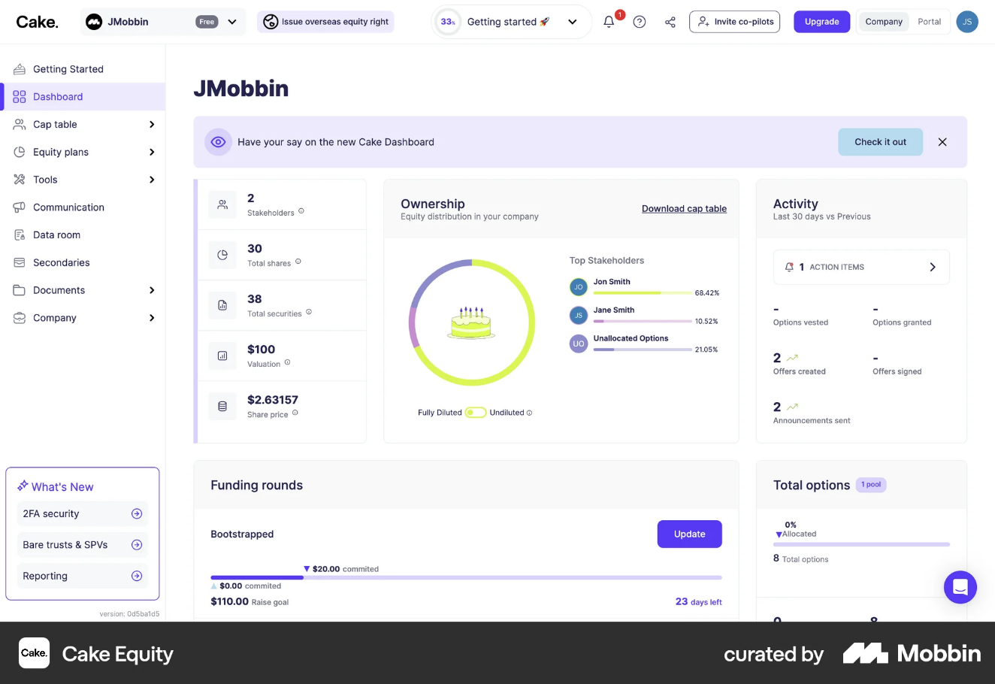
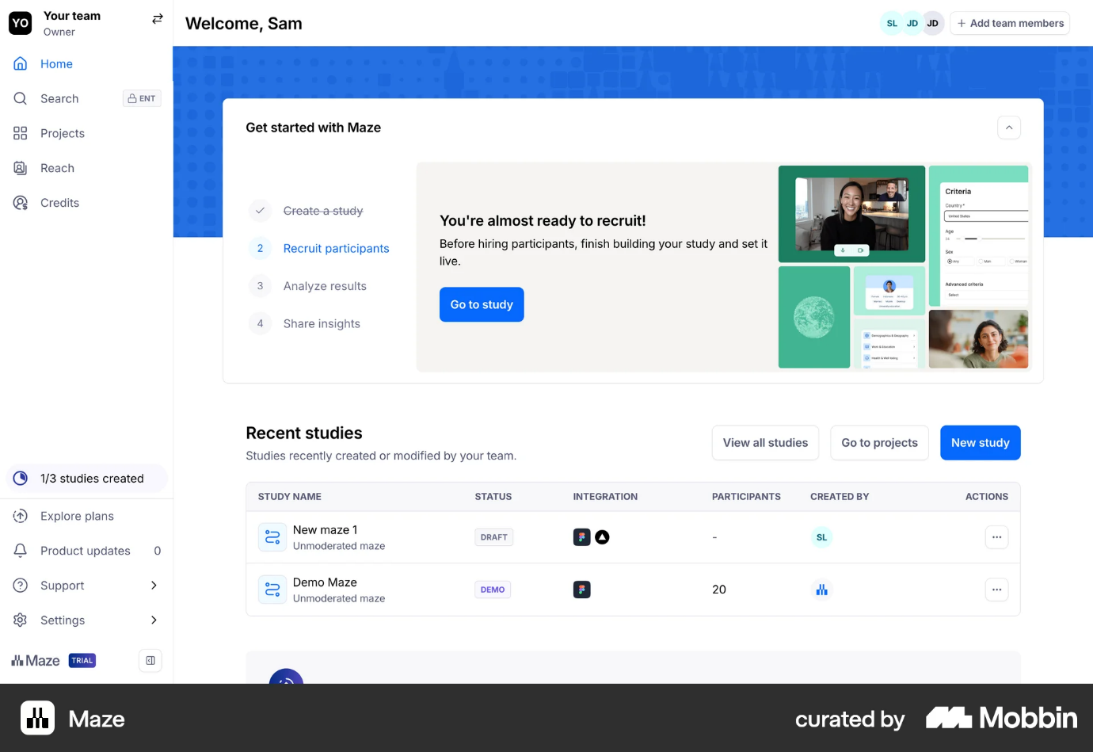

1. Design Philosophy
AdmitGuard is a control interface, not a marketing site.
The UI must feel:
- Structured, not decorative
- Calm, not loud
- Precise, not playful
- Authoritative, but not intimidating
The design should visually communicate:
- Strict vs soft validation clearly
- System state transparency
- Auditability and seriousness
- Professional institutional trust
No gradients screaming for attention. No decorative clutter. No Bootstrap default aesthetic.

2. Layout System
2.1 Overall App Layout
AdmitGuard uses a 3-zone dashboard layout:
- Left Sidebar Navigation
- Top Header Bar
- Main Content Area (Card-Based)
Structure:
| Sidebar | Header ----------------------------------- |
| | Content Area (Form / Audit / Dashboard) |

2.2 Sidebar Guidelines
Inspired by the clean vertical nav structure from modern SaaS dashboards.
Width
- 240px fixed
Background
- Light neutral gray (#F8F9FB)
- Slight contrast from main content
Navigation Items
- Icon + label
- 16px vertical spacing
- Active state:
  - Subtle colored background
  - Left border accent (4px)
  - Medium font weight
Navigation Items:
- Admission Form
- Audit Log
- Dashboard

2.3 Header Bar
Height: 64px
White background
Subtle bottom border (#EAECEF)
Contains:
- App name (AdmitGuard)
- Optional cohort label
- Dark/Light toggle (optional)
No oversized hero banners.

3. Grid & Spacing System
Adopt an 8px spacing system.
Spacing tokens:
- 8px (xs)
- 16px (sm)
- 24px (md)
- 32px (lg)
- 48px (xl)
Form sections separated by 32px minimum.
Cards have:
- 24px padding
- 16px internal spacing
No cramped layouts.
Whitespace is structure.

4. Card Design System
All major UI components exist inside cards.
Card style:
- Background: #FFFFFF
- Border radius: 12px
- Border: 1px solid #EAECEF
- Shadow: subtle (0 2px 8px rgba(0,0,0,0.04))
No heavy drop shadows.
Cards used for:
- Admission Form
- Dashboard Metrics
- Audit Log Table
- Confirmation Modal

5. Typography System
Tone: clean, modern, neutral.
Font:
- Inter / system-ui / similar sans-serif
Hierarchy:
H1 (Page Title)
- 24–28px
- Semi-bold
- Color: #1F2937
H2 (Section Title)
- 18–20px
- Medium weight
Field Labels:
- 14px
- Medium
- Color: #374151
Body Text:
- 14px
- Regular
- #4B5563
Validation Text:
- 13px
- Slightly tighter line height
No oversized display fonts.

6. Color System
The color system is functional, not decorative.
6.1 Primary Accent
Used sparingly:
- Buttons
- Active nav
- Highlights
Primary Blue:
- #2563EB (normal)
- #1D4ED8 (hover)

6.2 Semantic Colors (Critical for Validation)
Strict Error (Hard Block)
- Text: #B91C1C
- Background (subtle): #FEE2E2
- Border: #FCA5A5
Soft Warning (Override Allowed)
- Text: #92400E
- Background: #FEF3C7
- Border: #FCD34D
Success / Valid
- Text: #065F46
- Background: #D1FAE5
- Border: #6EE7B7
Flagged (Manager Review)
- Text: #7C2D12
- Background: #FFEDD5
- Border: #FDBA74
These states must be visually distinct at a glance.
No ambiguity between red and amber.

7. Form Field Design Guidelines
Each field must include:
- Label
- Input
- Validation Area (reserved space)
Avoid layout shift when errors appear.

7.1 Input Styles
Height: 44px
Border radius: 8px
Border: 1px solid #D1D5DB
Padding: 12px horizontal
On focus:
- Border color → primary blue
- Subtle shadow ring

7.2 Validation Behavior (Visual)
Strict Error:
- Red border
- Red inline message below
- Error icon optional
Soft Violation:
- Amber border
- Amber warning text
- Exception toggle appears below
Valid:
- Subtle green indicator
- No loud confirmation animations

8. Exception UI Design
This must be crystal clear.
When soft rule violated:
Show:
Amber info box:
"Candidate age exceeds allowed range (18–35)."
Below it:
Checkbox or toggle:
[ ] Request Exception
When toggled:
Show:
Textarea:
"Exception Rationale"
Design:
- 80px height minimum
- Character counter (optional)
- Validation message below
Exception approved state:
- Subtle green border around rationale box
Exception denied state:
- Red inline message
This is a legal traceability system — clarity matters.

9. Exception Counter Component
Position:
Near Submit Button (right aligned)
Display:
Active Exceptions: 2
If > 2:
Show banner above submit:
⚠ This candidate exceeds allowed exception threshold. Entry will be flagged.
Banner style:
Soft orange background
Rounded edges
16px padding

10. Buttons
Primary Button:
- Blue background
- White text
- 44px height
- Border radius 8px
Disabled:
- Gray background (#E5E7EB)
- Gray text (#9CA3AF)
- No pointer events
Secondary Button:
- White background
- Border
- Dark text
Destructive Button:
- Red background (#DC2626)
- White text

11. Confirmation Modal
Centered modal.
Max width: 600px
Includes:
- Summary of all fields
- Highlight exceptions
- Flag status
Layout:
Two-column summary grid.
Primary confirm button on right.
Cancel on left.
Backdrop:
Light dark overlay (rgba(0,0,0,0.4))

12. Audit Log Table Design
Inspired by structured SaaS tables.
Table Design:
- Full width card
- Header background: #F9FAFB
- Row hover state: subtle gray
Columns:
- Candidate Name
- Timestamp
- Exception Count
- Flagged
- Actions
Flagged:
Badge style:
Small rounded pill
Background: light orange
Text: dark orange
Expandable rows:
Accordion style
Soft animation

13. Dashboard Metrics Cards
Four summary cards at top:
- Total Submissions
- Total Exceptions
- Exception Rate
- Flagged Entries
Card Layout:
Icon (optional)
Large number
Small label
Numbers:
- 28–32px
- Bold
Clean, not flashy.

14. Micro-Interactions
Allowed:
- Subtle fade-in on validation pass
- Smooth accordion expand
- Hover transitions
Avoid:
- Bounce effects
- Cartoon animations
- Loud transitions
Professional software, not a game.

15. Dark Mode Guidelines (Optional)
Dark background:
#111827
Cards:
#1F2937
Text:
#F9FAFB
Semantic colors adjusted for contrast.
Must maintain:
Clear red vs amber distinction.

16. Accessibility Guidelines
- Contrast ratio ≥ 4.5:1
- Keyboard navigable form
- Labels tied to inputs
- Focus states visible
- Error messages screen-reader friendly
Validation must not rely on color alone.

17. Design Principles Checklist
Before shipping, confirm:
- Can a user instantly distinguish strict vs soft violations?
- Is the flagged state visually obvious?
- Does the interface feel calm and authoritative?
- Does spacing prevent cognitive overload?
- Is there zero ambiguity about submission status?
If not, redesign.

18. What We Avoid
- Generic Bootstrap look
- Overuse of gradients
- Overcrowded layout
- Ambiguous color signals
- Dense tables without breathing room
- Inline alerts that shift layout violently

19. Visual Identity Summary
AdmitGuard should feel like:
A compliance-grade SaaS tool
Built for serious institutional workflows
Clear, modern, restrained
Think: “internal admin dashboard with discipline,” not “consumer startup landing page.”

